**Amazing Race**

**Continuous Assessment for Enterprise .NET (2017)**

**Team 04**

|  |  |
| --- | --- |
| **Karthik Thirugnanasuriyan** | **E0146894** |
| **Nivritii Ramachandran** | **E0146471** |
| **Rachel Gnanaraj** | **E0146843** |
| **Varun Sampath** | **E0146861** |

**Application Overview**

* Web application to create and publish events. Also, to assign teams, pit stops and staffs to the events
* Live tracking of teams location and position during a live event in dashboard
* Displays all upcoming events in the dashboard
* Map feature to locate pit stops, teams and staff’s location for live event

**Pre-requirements**

* Compatible with **Google Chrome**. Some features (Map simulation, Date picker) may not work in other browsers.
* Simulator is hard coded for event “Race Singapore” in external python executable. Simulation will run even without the event.
* For live and upcoming event display in dashboard, edit the dates in the event edit page. Since event “Race Singapore” is simulated as current event, mention the current date for that event.

**Implementation**

ACE Amazing Race web application is implemented using **Entity Framework Code First** approach and **SignalR**.

*Database structure:*

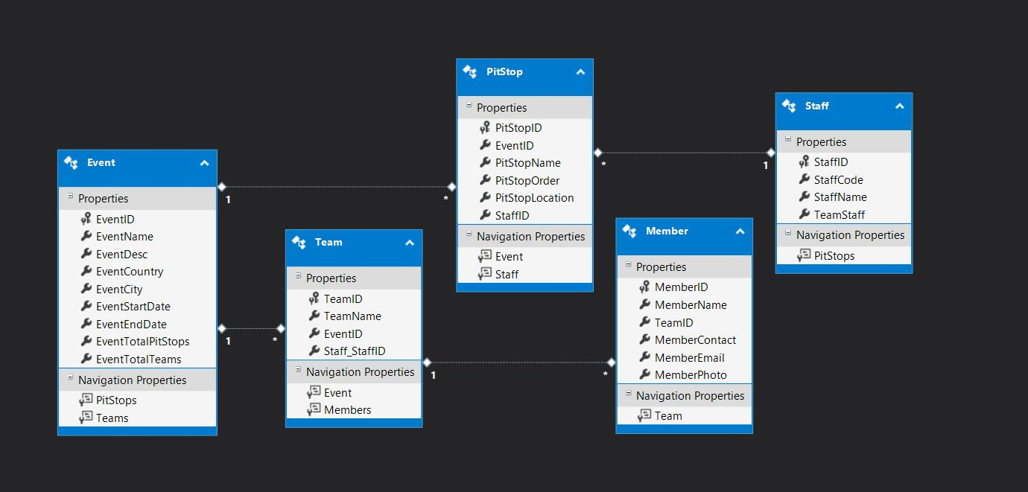

**Application Modules**

1. **Home Page (Public users without login):**

* Provides navigators for current event and upcoming events.
* Login and register button for staff users.

*Current Event Navigator*

* Dropdown list of current events
  + Current events will be retrieved based on the current date and will be populated in the dropdown list
* Simulator button
  + To run an external simulation via python executable which posts sensor values to the application via API controller
* Simulator executable:
  + External Python simulation executable that uses Http protocols to post JSON data to the specified application URL
* Map
  + Locates the pit-stops of the event
  + Tracks the location of teams
  + Updates Pit Stop, Team, Staff with Different markers
  + Draws Polylines for the Teams to differentiate their paths for easy visual
* Leaderboard Table
  + Tracks teams’ ranking based on the time the pit stop was cleared and the distance to the next pit stop

*Upcoming Events*

* Displays the list of future events with the event date

1. **Home Page (Logged-in Admin Users)**

* Staff users are required login from main homepage.
* Have access to the contents of current and upcoming events navigators as the public users.
* Additionally, in the Map feature, the location of the staff will also be tracked.

*Staff only features*

* Access for Event, Team, Member, Pit Stop, Staff only when logged in
* Following order should be followed for Overall Event Creation
  + Event 🡪 Team 🡪 Member
  + Event 🡪 Staff 🡪Pit Stop

1. **Common functionalities (Index, Create, Edit, Details, Delete for Event, Team, Member, Staff, Pitstop)**

* Index: Displays the created list from the database
* Create: A web form page which gets the input from the admin staff and stores in database
* Edit: Retrieves the values from the database and displays to the staff which can be updated and saved in DB
* Details: Retrieves the values from the database and displays to the staff which is read-only
* Delete: Retrieves the values from the database and displays to the staff which can be deleted from the DB.

1. **Additional features**

* Event Index: Event select option provided which when selected lists out the details of Pitstops, Teams tagged to the Event and Members tagged to the team
* Team Index: Team select option provided which when selected lists out the details of Members tagged to the team
* Pitstop Create: Displays map for getting pit stop location. Sets the location by clicking on the map. On clicking, using reverse geocoding of google map, retrieves the address of the pit stop location set.
* Pitstop Edit: Using geocoding feature from google map converts the address to the location and sets on the map. User can edit the location like pit stop create.
* Member Create: User can select and upload the member photo from the local device which is saved as byte in the DB.
* Member Edit: Displays the member photo which is retrieved as byte and converted to image
* Home Index: Automatic Slideshow of pre-set images

1. **Extra features added after the presentation comments**

* Added security features
* Changed the Event index select display order of pit stops and teams as per the suggestion
* Extra feature Demo link HERE:

